3. Basic Workflow: Integrated User Journeys
This section provides a detailed, step-by-step guide on how each specific user type can navigate MyDiet to fulfill their health and social objectives.
3.1 The Personalized Nutrition Workflow (For Health Users)
Primary Goal: To establish a data-driven nutritional baseline and maintain a healthy diet through automated planning and AI logging.
Step 1: Establishing Your Nutritional Profile
- Access the Module: Click the Plan tab on the navigation bar.
- Physical Data Entry: Input your Age, Height (cm), and Weight (kg) .
- Activity & Gender Selection: Select your gender and current activity level (ranging from Sedentary to Very Active).
- Constraint Definition: Enter any Allergies.
  - Note: Multiple items must be separated by commas (e.g., Peanuts, Milk) for the system to filter the 165,000+ recipe database accurately.
- Execution: Click Generate My Plan.
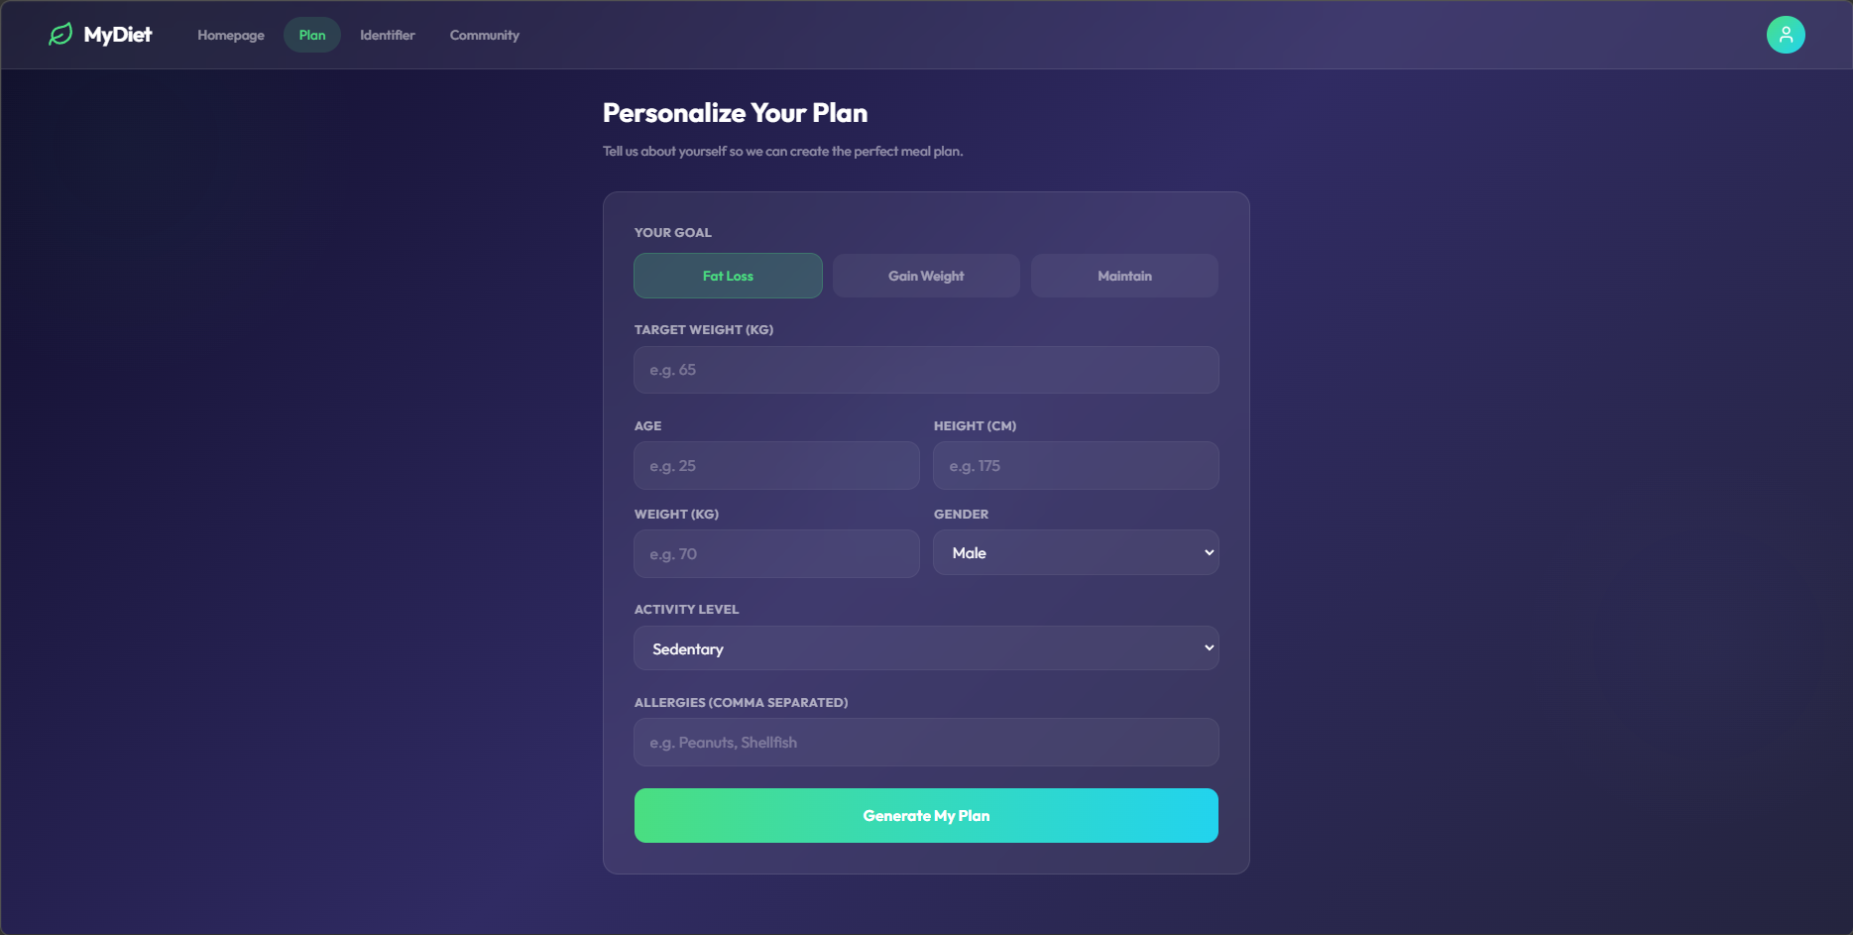
Step 2: Managing the Weekly Plan
- Review Daily Macros: Click on any specific day (e.g., Monday) to view the calculated Calories, Protein, Carbs, and Fats for each meal.
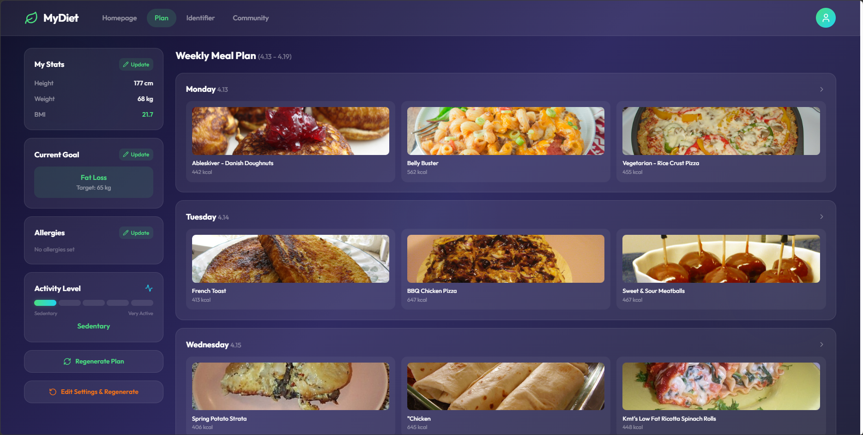
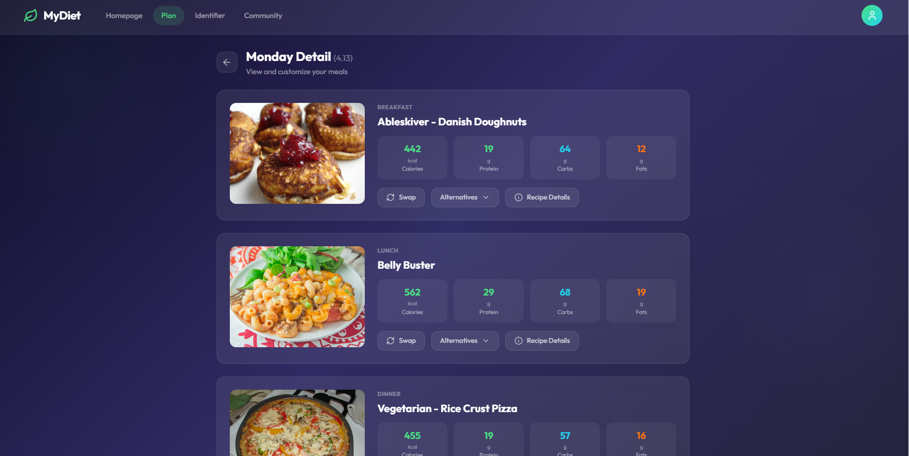
- Recipe Instructions: Click Recipe Details on any meal card to view the ingredients and step-by-step cooking instructions.
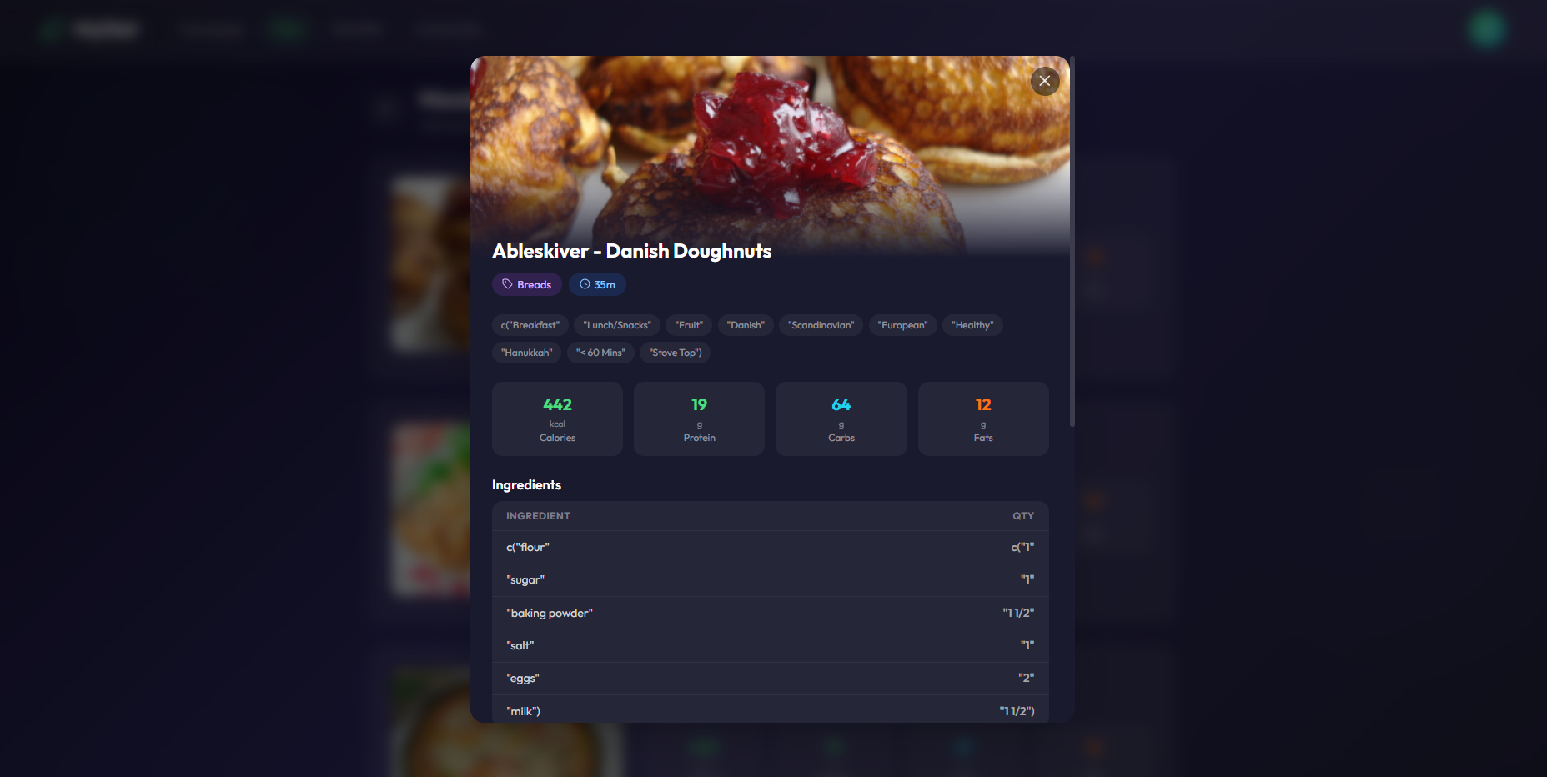
- Customization:
  - Swap: Click the Swap button to automatically replace a meal with the next highest-scoring recipe that fits your macros.
  - Alternatives: Click the Alternatives dropdown to manually choose from the top 3 backup recipes.
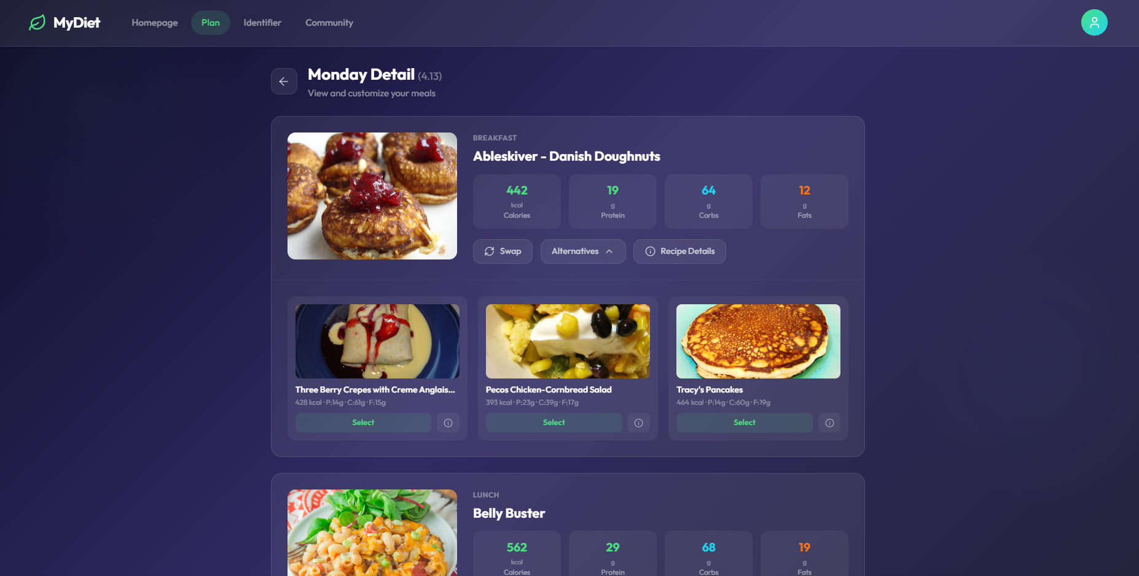
Step 3: Real-Time AI Food Logging
- Access Identifier: Navigate to the Identifier tab.
- Image Upload: Drag-and-drop or click to upload a photo of your meal.
- Verification: Review the AI-detected food items, confidence levels, and estimated calories.
- Logging: Click Confirm & Log Today to save the intake data to your history.
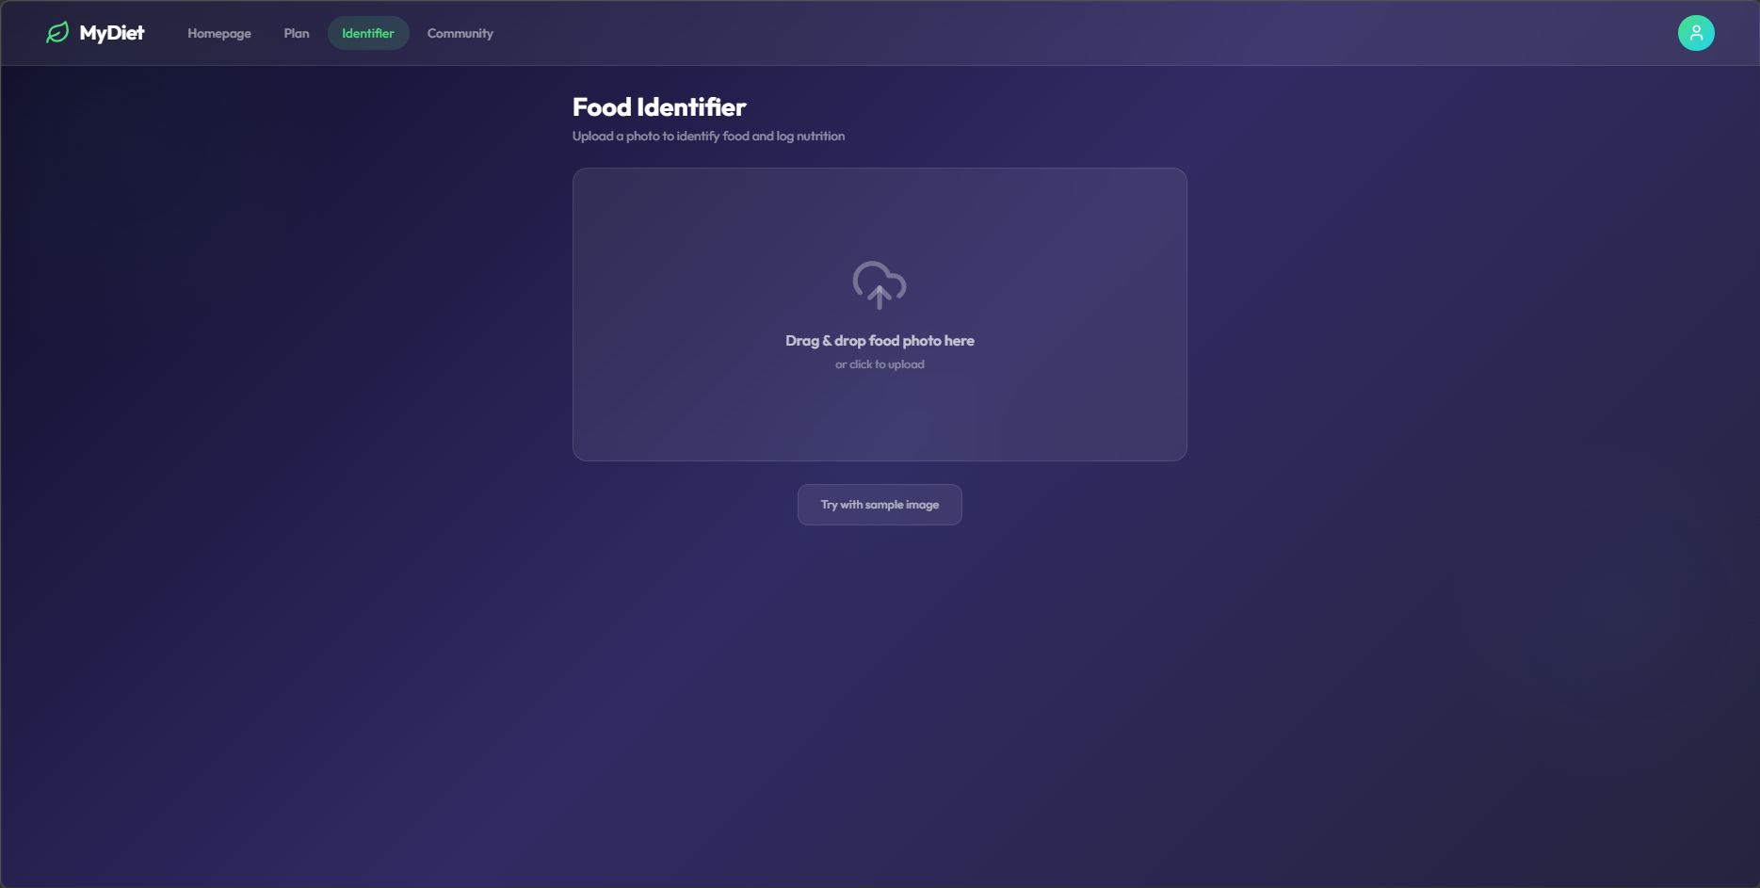
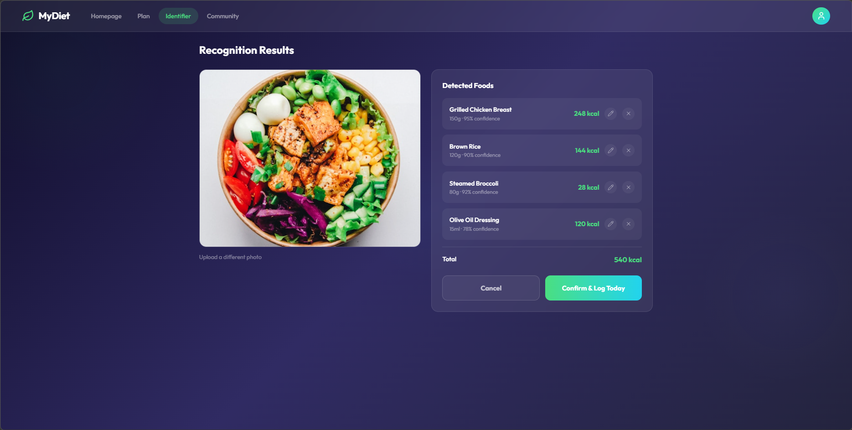
Step 4: Daily Progress Monitoring & Logging
- Monitor Intake Progress: Click the Homepage tab. This dashboard acts as your central control center.
  - Calendar: Use the date selector at the top to view your daily status and streaks.
  - Intake Visualization: Monitor the central Progress Ring and the Macronutrient Bars (Protein, Carbs, Fats) to see how much of your daily quota has been consumed.
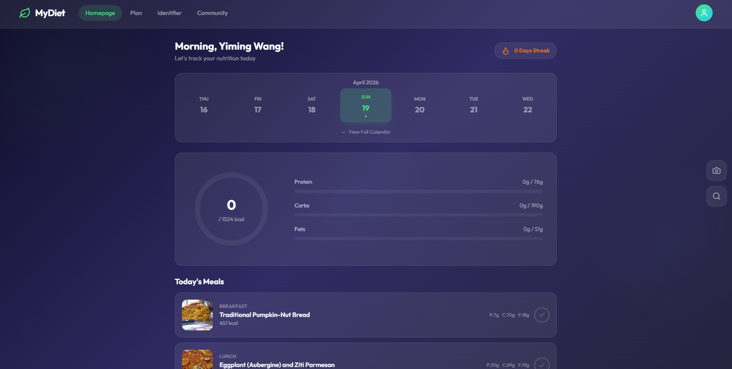
- Log Scheduled Meals:
  - In the Today's Meals section, click the checkmark (√) next to your Breakfast, Lunch, or Dinner once consumed.
  - The progress ring and bars will automatically increase to reflect the nutritional value, accompanied by a visual "confetti" confirmation.
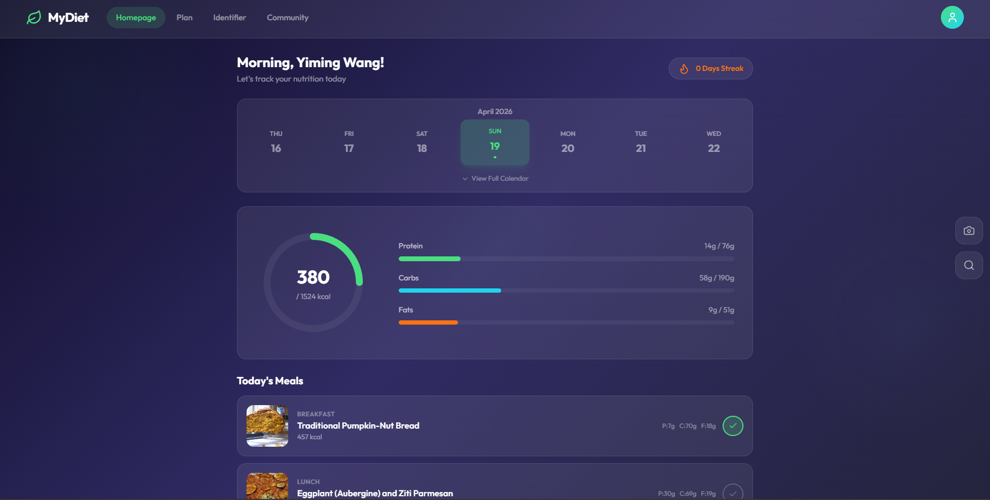
- Manage Supplemental Intake (Extra Meals):
  - Items processed through the Identifier appear in the Extra Meals section below your daily plan.
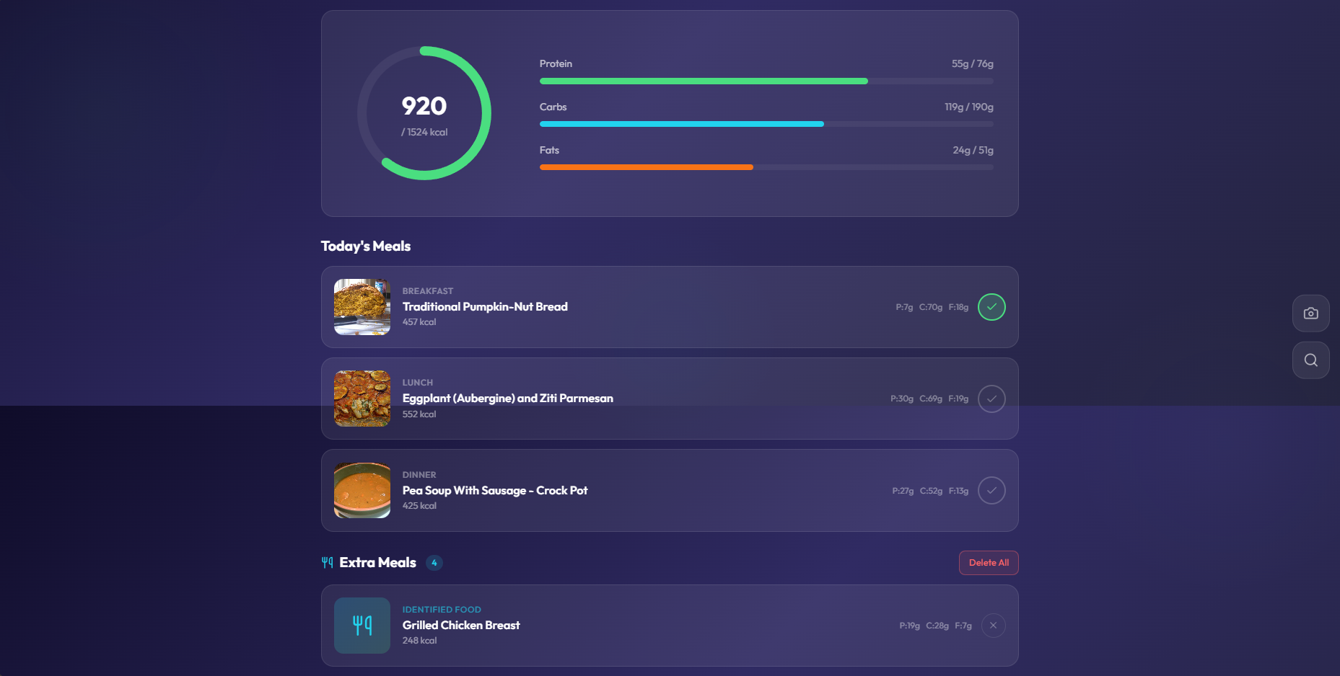
  - Individual Removal: Click the close (×) icon on a specific meal card to delete it.
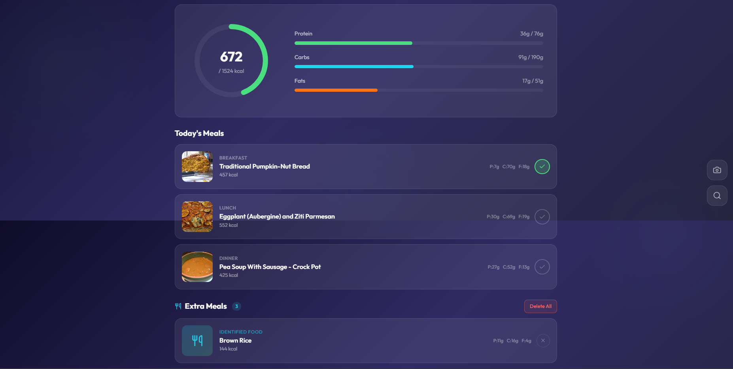
  - Batch Clear: Click Delete All to remove all extra meal entries and reset the corresponding intake values on your progress bars.
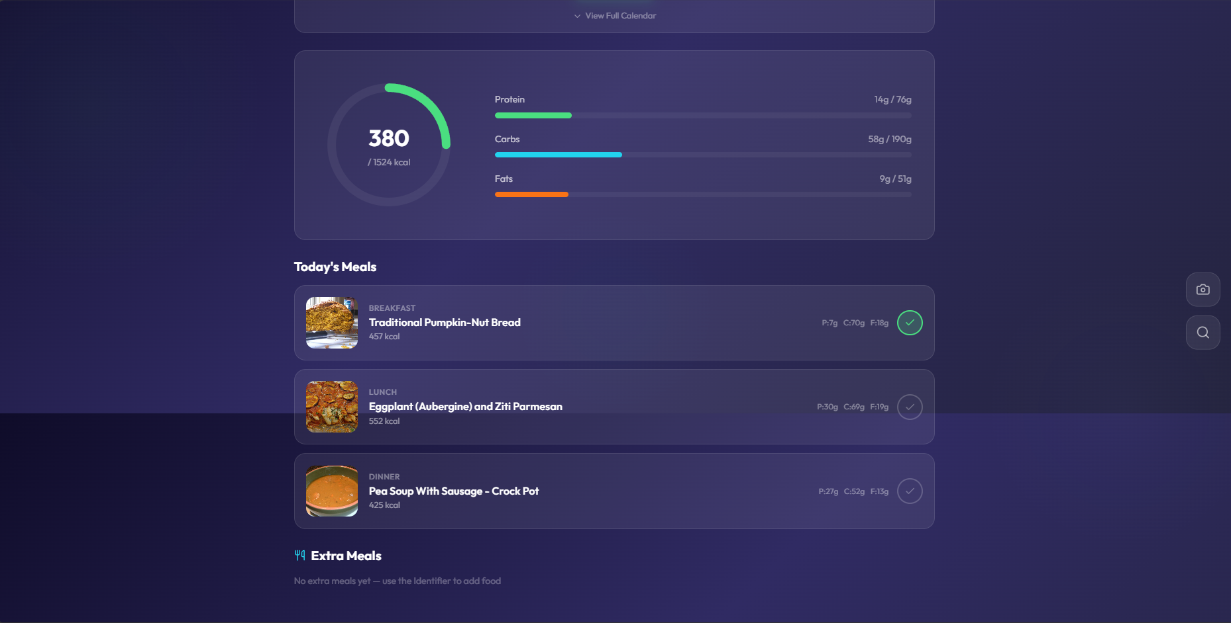

3.2 The Social Interaction Workflow (For Community Users)
Primary Goal: To gain social support, share dietary experiences, and stay motivated through interaction.
Step 1: Content Discovery
- Browsing: Navigate to the Community tab to view Recommended or Trending posts.
- Targeted Search: Use the Search Bar or Tags (e.g., #StayHealthy) to find specific recipes or health tips.
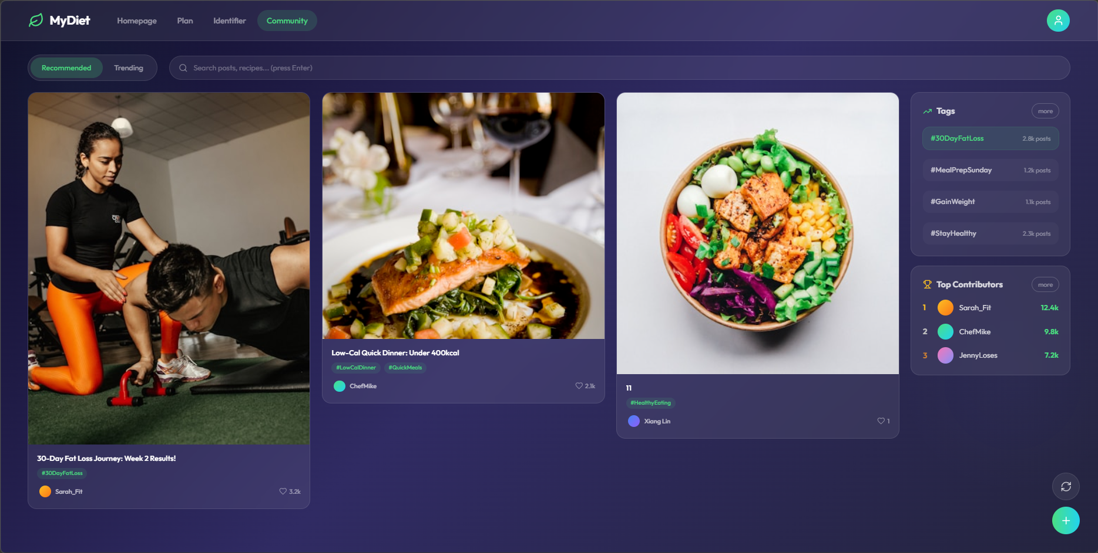
Step 2: Community Engagement
- Post Details: Click any post to view full content, high-quality images, and other users' feedback.
- Interactive Support: Support your peers by clicking Like, or using the Comment/Reply features to share encouragements.
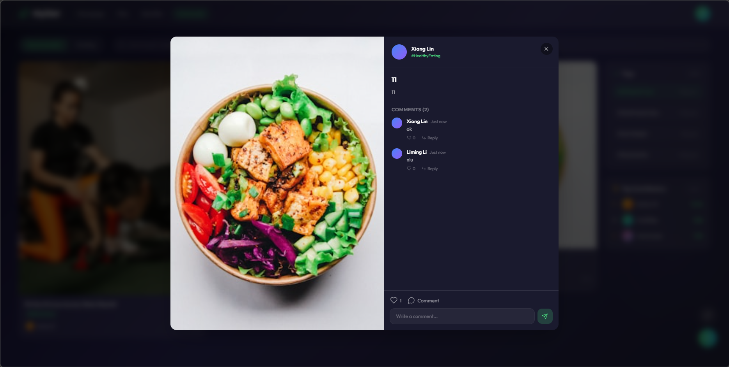
Step 3: Creating and Sharing Posts
- Initiation: Click the green "+" button at the bottom right.
- Content Creation: Input your post title and content, upload photos of your progress, and add comma-separated tags.
- Publication: Click Post to share your journey with the community.
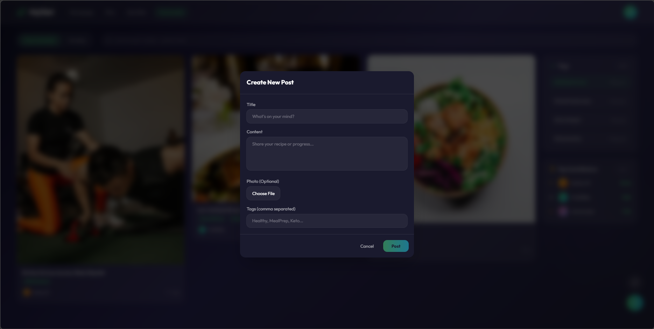
3.3 The Platform Management Workflow (For Administrators)
Primary Goal: To ensure platform stability, moderate community interactions, and resolve technical issues.
Step 1: Operational Monitoring
- System Stability: Administrators ensure the platform remains accessible via modern browsers and maintains a stable connection for all active users.
Step 2: Content Moderation
- Guideline Enforcement: Admins review community interactions to ensure users respect community guidelines, removing any inappropriate or offensive content.
Step 3: Support and Troubleshooting
- Issue Resolution: Administrators handle account-related issues, such as user authentication failures or troubleshooting form validation errors.

